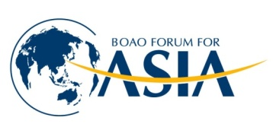
BFA MEMBERSHIP APPLICATION FORM
博鳌亚洲论坛会员申请表

Category of Membership 申请会员类别

Diamond Platinum Ordinary
钻石 白金 普通

16 years / 16年 16 years / 16年 3 years / 3年
RMB￥3,000,000 RMB￥1,800,000 RMB￥150,000

5 years / 5年 5 years / 5年
RMB￥1,200,000 RMB￥800,000

3 years / 3年 3 years / 3年
RMB￥900,000 RMB￥600,000

Company / Organization Applicant 公司 / 社团申请人资料

Company/Organization Name in Chinese and/or English
公司/社团名称(中英文)

钻石

钻石

Position
职务

钻石

钻石

Name of Chief Executive
负责人姓名

钻石

Chop and Authorized Signature
法人代表盖章签字

Business Scope
业务范围

Contact Information 通讯资料

钻石

Position
职务

钻石

钻石

Contact Person
联系人

钻石

钻石

Fax
传真号码

钻石

钻石

Telephone
联系电话

钻石

钻石

Official Website
官方网站

钻石

钻石

E-mail
电子邮箱

钻石

钻石

Mailing Address
通讯地址

钻石

dd日 mm月 yy 年

Date
申请日期

钻石

Remarks
备注

钻石

